Ideation Phase
Brainstorm & Idea Prioritization Template

Date | 31 January 2025
Team ID | LTVIP2026TMIDS76805
Project Name | Online Payments Fraud Detection using Machine Learning
Maximum Marks | 4 Marks

Brainstorm & Idea Prioritization Template:
Brainstorming provides a free and open environment that encourages everyone within a team to participate in the creative thinking process that leads to problem solving. Prioritizing volume over value, out-of-the-box ideas are welcome and built upon, and all participants are encouraged to collaborate, helping each other develop a rich amount of creative solutions.
Use this template in your own brainstorming sessions so your team can unleash their imagination and start shaping concepts even if you're not sitting in the same room.
Reference: https://www.mural.co/templates/brainstorm-and-idea-prioritization
Step-1: Team Gathering, Collaboration and Select the Problem Statement
The team conducted a collaborative discussion session to identify real-world problems in the financial technology domain. During the discussion, we analyzed the rapid growth of digital payment systems and the increasing number of online fraud cases.
After evaluating multiple ideas, the team selected the following problem statement:
Problem Statement:
To develop a Machine Learning based system that detects fraudulent online payment transactions in real time and helps prevent financial losses.
The problem was selected because:
- Online fraud is increasing rapidly.
- Businesses suffer financial losses due to fraudulent transactions.
- Customers lose trust in digital payment systems.
- There is a need for intelligent and automated fraud detection systems.
All team members agreed that this problem has strong real-world impact and practical implementation scope.



Step-2: Brainstorm, Idea Listing and Grouping
During the brainstorming session, team members freely shared ideas without judging or rejecting any concept. The focus was on generating maximum ideas.
Ideas Generated:
- Build a real-time fraud detection model.
- Use classification algorithms like Random Forest and XGBoost.
- Analyze transaction amount and balance differences.
- Detect unusual transaction patterns.
- Create a web application using Flask.
- Display fraud probability score.
- Implement model retraining for adaptive learning.
- Use data visualization for fraud analysis.
Idea Grouping:
After listing ideas, we grouped them into categories:
1. Data & Model Ideas
- Use supervised learning
- Train classification models
- Evaluate using Precision and Recall
2. System Development Ideas
- Develop Flask web application
- Create input form for transactions
- Display prediction results clearly
3. Security & Improvement Ideas
- Adaptive fraud detection
- Continuous model improvement
- Reduce false positives
This grouping helped organize the ideas systematically.

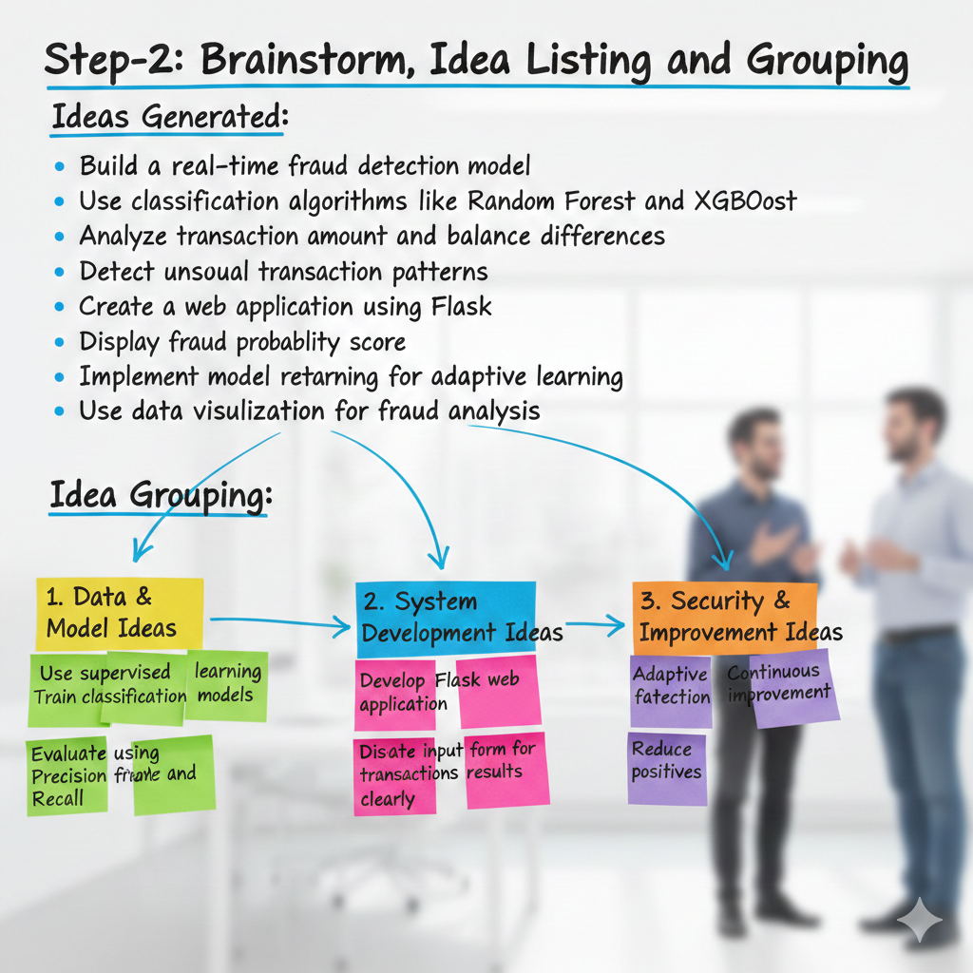

Step-3: Idea Prioritization
After brainstorming, the team prioritized ideas based on:
- Feasibility
- Impact
- Implementation time
- Technical complexity
High Priority Ideas:
- Build a classification-based fraud detection model.
- Use Random Forest or XGBoost for better accuracy.
- Develop a Flask-based web interface.
- Provide real-time fraud prediction output.
Medium Priority Ideas:
- Add fraud probability visualization.
- Implement advanced evaluation metrics.
Low Priority Ideas:
- Advanced dashboard analytics.
- Complex UI enhancements.

Final Selected Approach:
The team decided to:
- Use supervised machine learning classification.
- Train the model on a fraud detection dataset.
- Evaluate performance using accuracy, precision, recall, and F1-score.
- Deploy the model using Flask with a simple user interface.

Conclusion of Ideation Phase
The brainstorming session helped the team generate multiple innovative ideas and systematically prioritize them. By selecting the most impactful and feasible approach, the team established a clear development roadmap for the Online Payments Fraud Detection system.

